TETRIS

COMP 2659 Course Project Stage 1: Game Specification (Initial Draft)
Group: Marusia Luciuk (mluci567@mtroyal.ca), Andrew Walsh (awals985@mtroyal.ca)
Initial Draft Due: January 19, 2024

Table Of Contents
Table Of Contents 2
1. General Game Overview 3
2. Game Play Details for Core 1-Player Version 4
i) Objectives and Rules 4
ii) Block Movement and Placement 5
iii) Play Area 6
3. Objects 7
4. Events 11
i) Asynchronous (Input) Events 11
ii) Synchronous (Timed) Events 13
iii) Condition-Based (Cascaded) Events 13
5. Hypothetical Game Session 15
6. Game Play Details for Core 2-Player Version 16
i) 2-Player Game Concept: 16
a) Additional Thoughts: 16
7. Sound Effects 17
i) Asynchronous 17
ii) Synchronous 17
iii) Background music 17
8. Additional Features (Time Permitted) 18

1. General Game Overview
The game involves manipulating and arranging falling blocks of shapes into a horizontal line without gaps. As it falls, the player is able to shift the block left and right, rotate the block clockwise and counterclockwise, and drop the block at two speeds. When a line is completed, it disappears, awarding points to the player and freeing up space. The speed at which the blocks fall increases with gameplay, challenging the player by requiring quick decision-making and strategic placement. The ultimate goal is to continue clearing lines without letting the blocks reach the top of the screen, which constitutes a loss.

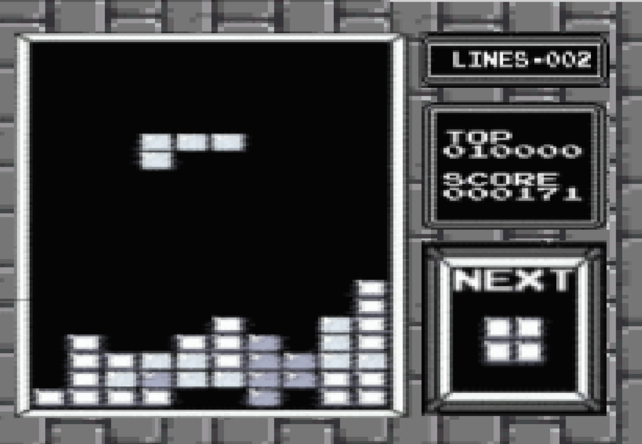
General Game Concept:

2. Game Play Details for Core 1-Player Version

i) Objectives and Rules
The game focuses on the manipulation of geometric shapes known as Tetrominoes, which are composed of four-square blocks each and the gameplay area is limited to a set space which is sized at 10 blocks wide (horizontally) and 20 blocks tall (vertically). When the game starts, these Tetrominoes fall, one at a time, from the top of the game screen to the bottom. A new Tetromino is given to the player only after the current Tetromino piece in play has been placed. The player's objective is to arrange them to form complete horizontal lines when placed using movement and rotational changes. Movement is restricted to left, right, and down, whereas rotations are restricted to 90-degree increments either clockwise or counterclockwise. When a player completes a line, that line is cleared horizontally, and any above blocks fall downwards into empty spaces available below.
When a line is cleared, the player is awarded points to their score. The base points awarded are 40 for a cleared line. Level scoring multipliers will be based on the level the player is currently on, where each level increment increases the line clearing points awarded by 40. For example, ‘level 1’ will award 40 points per line cleared, and ‘level 2’ will award 80 points. Levels will increment every 10 cleared lines.
As the player progresses through each level, the speed at which the Tetrominoes fall increases, adding a degree of challenge, strategy, and urgency. Players must think quickly and strategically to rotate and position the falling Tetromino pieces to fill gaps and create complete horizontal lines. A player is able to complete more than one horizontal line at the same time, such as a piece being placed where two or more lines would be completed. The game continues until the player’s stacked Tetrominoes reach the top of the play area resulting in a game over. The primary goal is to prevent the stacking Tetrominoes from reaching the top of the play area and achieve the highest score you can.

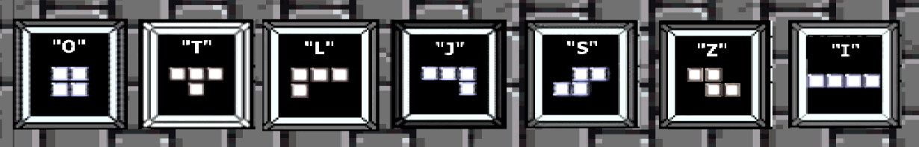
ii) Block Movement and Placement

The seven different blocks, each varying from 60x60 pixels to 120x30 pixels, are bound by the same movement and placement rules. Each block consists of 4 “segments”, each measuring about 30x30 pixels. All blocks move two dimensionally on the screen, falling continuously in a downwards direction unless acted upon by the player. Actions that can be taken by a player consist of a left shift, a right shift, a CC rotation, a CW rotation, a quick drop and a slow drop. A left shift will move the block a distance of 30 pixels, or one “segment”, to the left and a right shift will move the block 30 pixels to the right. A CC rotation will rotate the block by 90 degrees about its centermost point to the right, and a CW rotation will rotate the block by 90 degrees about its centermost point to the left. A quick drop will accelerate the speed at which the block falls naturally by 3 times, a slow drop will accelerate the speed at which the block falls naturally by 1.5 times.
The velocity of these actions is measured in pixels per clock tick. Falling blocks will always appear in the passive play area and can be acted upon as soon as they are visible on screen. The player may take action on a block until it collides with any top portion of the active play area, at which point it is permanently placed.

iii) Play Area
The play area consists of two main components, the “active” play area and the “passive” play area and is confined by two side edges (Left and Right), a top edge and a bottom edge. The entire play area measures 300 x 600 pixels, but the size of the active and passive areas is determined by the actions of the player. The left, right and bottom edges serve no functional purpose other than to contain the play area, however the top edge marks the limit to the active play area. The passive play area represents the space available to the player to shift and adjust a falling block, whereas the active play area represents the area taken by previously placed blocks. The size of the active play area is the width of the total play area (300 pixels) times the distance in pixels between the bottom edge and the topmost point of the highest placed block. The size of the passive play area is the width of the total play area (300 pixels) times the height of the total play area (600 pixels) minus the height of the active play area.
A collision of a block with the top edge of the active play area can result in two different outcomes; either 1 or more rows are completed and “cleared”, increasing the score by 40 points per row cleared and decreasing the height of the active play area by 30 pixels per row cleared, or no rows are completed and the active play area is increased by the height in pixels of the collided block. In the event of a collision of the active play area and the top edge of the play area, the game is lost and will terminate. When the game ends, a message indicating the players final score and the lifetime top score will be displayed.

3. Objects

Object Name | Properties | Behaviors | Image
“O” Block | Size: 60x60 pixels (constant int pair: h,w)  Position: (Integer pair: x,y)  Vertical velocity: int  Vertical direction: int  Rotation: int  *Properties other than size are identical across all Block objects | -Shift left  -Shift right  -CC rotate  -CW rotate  -Slow drop  -Fast drop  -Collide  *Behaviors are identical across all Block objects | 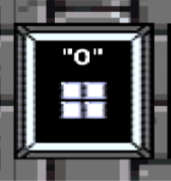
“T” Block | Size: 60x90 pixels (constant int pair: h,w)  “ | “ | 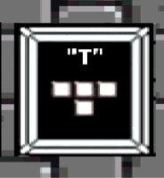
“L” Block | Size: 60x90 pixels (constant int pair: h,w)  “ | “ | 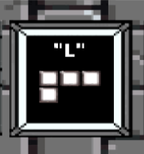
“J” Block | Size: 60x90 pixels (constant int pair: h,w)  “ | “ | 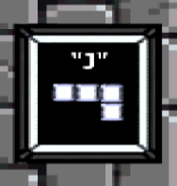
“S” Block | Size: 60x90 pixels(constant int pair: h,w)  “ | “ | 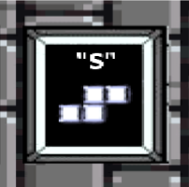
“Z” Block | Size: 60x90 pixels(constant int pair: h,w)  “ | “ | 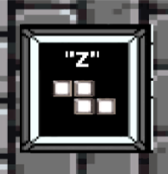
“I” Block | Size: 30x120 pixels  “ | “ | 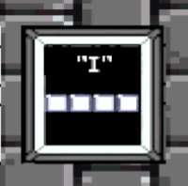
“Next” Block | Position: constant  int pair (x, y)  Size: 210x210 pixels (constant int pair  (h, w))  Value: O,T,L,J,S,Z, or I Block | -update | 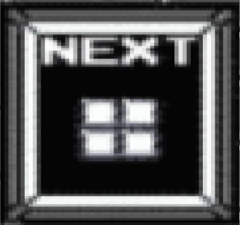
Passive Play Area | Size: int pair (h, w)  h = height of the total play area (600 pixels) - height of the active play area  w = total play area (300 pixels) | -update height  -update width | 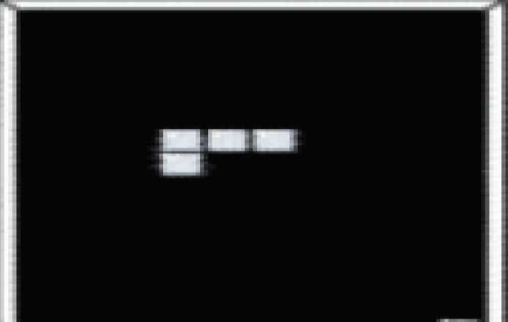
Active Play Area | Size: int pair (h, w)  w = width of the total play area (300 pixels)  h = distance in pixels between the bottom edge and the topmost point of the highest placed block  Game field: multidimensional (10x20?) array representing what 30x30 pixel sections of the play area are occupied by placed blocks | -update height  -update width  -collision (with block)  -collision (with upper bound)  -clear row: each row of the game field needs to be examined. If a row has a block in each column, then the row has to be eliminated. | 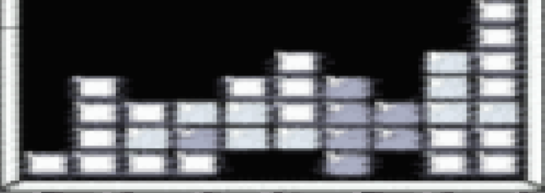
Scoreboard | Position: constant  int pair (x, y)  Size: constant  int pair (h, w)  Top Score: Int value  Score: Int value | -update top score  -update score | 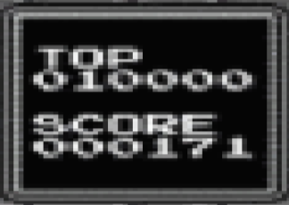

4. Events

i) Asynchronous (Input) Events

Event Name | Triggering Input Event | Description
Basic Tetromino Movement | Whenever a player presses one of the following keys:  - Left Arrow Key  - Right Arrow Key  - Down Arrow Key | In both Player 1 and Player 2 modes:  - The Tetromino piece will move in the direction of the key pressed, with down being a slightly faster drop than the normal drop rate AKA “Soft Drop”.
Tetromino Fast Drop | If the player presses the ‘Spacebar’ key. | In both Player 1 and Player 2 modes:  - The Tetromino piece descends at the fastest rate, double that of a ‘Soft Drop’.
Tetromino Rotation | If the player presses either:  - ‘Z’ key  or  - ‘X’ key. | In both Player 1 and Player 2 modes:  - The Tetromino piece will rotate by 90 degrees on its origin piece counterclockwise for the ‘Z’ key, or clockwise for the ‘X’ key.
Quit | When a player presses the ‘ESC’ key. | The game quits from the current session. This can either return to the menu or exit the game entirely (TBD).

ii) Synchronous (Timed) Events

Event Name | Triggering Timed Event | Description
Tetromino Basic Descending Move | Piece is in play for the player. | The Tetromino piece will fall at a starting rate of 1 block downwards every 2 seconds. This rate increases as the player progresses.

iii) Condition-Based (Cascaded) Events

Event Name | Triggering Condition Event | Description
Tetromino Basic Descending Move | A Tetromino piece spawns and is in play for the player. | The Tetromino piece will fall at a starting rate of 1 block downwards every 2 seconds. This rate increases as the player progresses.
Clear Line | If a horizontal line of blocks is filled by a player piece placement. | The line that is filled will clear.
Speed Increase | The gameplay level increments. | When the player moves up a level, the rate the Tetromino pieces descend increases as well.
Score Increase | If a player clears a line. | When a line is cleared, the player is awarded points according to the level points modifier. This increments the score by the desired amount.
Level Increase | A player clears a total of 10 lines in a level. | Once the player has cleared 10 lines, the level increments by 1.

5. Hypothetical Game Session
The game starts off with a splash screen, and the options 1-Player, 2-Player, and Quit are displayed. A selection is made on 1-Player and the game Tetris loads to the screen for a 1-player game. Background music begins to play and the first block spawns into view at the top of the screen, the block begins to slowly descend downwards. The player can move the block left, right, or descend the block at two different speeds -- a soft descend, or a fast descend. The player presses the ‘spacebar’ key, prompting a block interaction ‘beep’ sound to play, descending the first block to the bottom of the play area quickly. The block is placed at the bottom of the screen, a ‘thud’ sound plays, and another randomly selected Tetromino is spawned at the top of the screen. Gameplay continues like this for multiple block placements until the player places a piece in such a way that a horizontal line is completed. A ‘chime’ sound plays, the line the player completed is cleared, the line count is incremented, the player is awarded 40 points (for level 1), and any “floating” rows that may have been seated on the now cleared row line fall into the newly made space, retaining its shape as if it is one large piece. The player eventually clears 10 lines and the level increments by one. Now the Tetromino blocks begin to descend at a slightly faster pace. Gameplay continues as before, however cleared line points now award 80 points rather than 40. The game continues for the player until their respective actively placed pieces touch the top of the play area screen. This occurs for our player on level 6, with a score of 6960. The game returns to the main menu, and the player can choose to play again or quit the game, they choose ‘Quit’ option and the game closes.

6. Game Play Details for Core 2-Player Version

i) 2-Player Game Concept:
2-Players will compete in a battle to either knock out their opponent or achieve the highest score within a set time frame via a countdown timer. As a player completes a set number of lines, let's say five, this event will trigger a play area shrinkage to the opposing area via a top hindering line. This hindering line will stretch from one side of the play area to the other on only one line effectively reducing that player's available play space and offsetting where that player's drop block spawns. Additionally, these hindering lines can accumulate, reducing a player's play area further. A player is knocked-out of the game if the bottom-most hindering line collides with the player's currently placed pieces. Furthermore, if a player does complete the number of lines required to send a hindering line to the opposing player, they remove one line on their side as well. The game concludes either with a time-out or a collision of hindering blocks with in-play blocks.

a) Additional Thoughts:
- Players could possibly receive different types of pieces throughout the game, or they could receive the same pieces.

7. Sound Effects

i) Asynchronous
“Action taken on block” : When the user manipulates a block (by shifting, rotating or dropping it), an unassuming yet optimistic beep will play.

ii) Synchronous
“Landing block” : When a block reaches its resting position on the screen a soft, understated thud will play
“Cleared line” : When the player successfully arranges the given shapes into a line with no gaps, therefore “clearing” it, a celebratory bell-like chime will play.

iii) Background music
For the background music, a simplified version of the iconic Tetris theme song will play in a 2-bar loop.

8. Additional Features (Time Permitted)
- Implement a timer system for ‘2-Player’ games.

- Lines completed counter.

- Cyclic piece randomizer.
  - For clarity: A player receives 1 of the 7 pieces randomly, this piece is removed from the available remaining pieces that can be received until all 7 have been given. The available pieces resets after this cycle and they are randomly chosen again. This guarantees that a player will receive 1 of each piece in a cycle, but in a random order per cycle.

